**Project Start Date: 11-Sep-2018**

**Project Submission Date: 11-Oct-2018**

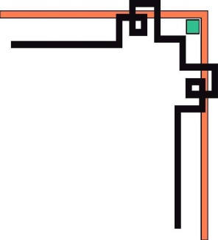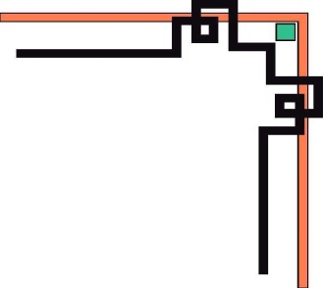

**eProject SEM-3**

**.NET**

**Project: Karnel Travel**

***Group 3:***

Student1058384 HUY DANG TUAN

Student1007818 SON PHAM NGUYEN HOANG

Student1111738 PHONG TRAN TRUNG

Student989084 NHI NGUYEN THI YEN

***Supervisor:***

MY LINH ONG THI

**Table of Contents**

1. Problem Definition 3

2. Customer requirement specification (CRS) 5

2.1 Client: Karnel Travel Company 5

2.2 Business/Project Objective 5

2.3 Requirements and Scope 5

3. Architecture & Design of System 8

4. Data Flow Diagrams (DFD) 9

4.1 Context diagram: DFD Level 1 9

4.2 DFD Level 1 10

4.3 DFD Level 2.1 11

4.4 DFD Level 2.2 12

4.5 DFD Level 2.3 13

4.6 DFD Level 2.4 14

4.7 DFD Level 2.5 15

4.8 DFD Level 2.6 16

4.9 DFD Level 2.7 17

5 Flow Charts 18

1.1 Create Account Admin 18

1.2 Login Adminstrator 19

1.3 Insert: Restaurants, Hotels, Foods, Vehicle, Rooms, Tourist Spot, Transportation 20

1.4 Update: Restaurants, Hotels, Foods, Vehicle, Rooms, Tourist Spot, Transportation 21

1.5 Delete: Restaurants, Hotels, Foods, Vehicle, Rooms, Tourist Spot, Transportation 22

1.6 Search 23

1.7 Book Travel (Cart) 24

1.8 Check out Book travel 25

6 Entity Relationship Diagrams 25

7 Data modeling (SQL SERVER) 26

8 Data Dictionary 27

9.1 Admin 28

9.2 Customer 28

9.3 TripDetails 28

9.4 ImgFoods 29

9.5 Feedback 29

9.6 Foods 29

9.7 ImgRestaurants 30

9.8 Restaurants 30

9.9 ImgRoom 30

9.10 Room 30

9.11 ImgHotel 31

9.12 Hotel 31

9.13 Transportations 31

9.14 Abouts 32

9.15 Vehicle 32

9.16 Trip 33

9.17 Location 33

9.18 ImgTouristSpot 33

9.19 TouristSpot 34

9.20 PaymentMethod 34

10 Site Map 34

10.1 Admin 35

10.2 User 36

11 Task Sheet 37

12 Check list Validation 50

13 Submission Checklist 50

14 User Guid and Install eProject 51

14.1 System Requirement: 51

14.2 Install and Run App 51

13.2.1 SQL Server local (2014) 51

14.3 GUI 58

13.3.1. Config SQL 2014 and VS 2017 Pro 58

13.3.2. Administrator 58

13.3.3. User 63

1. **Problem Definition**

***(Form No. 1/eProjects/PS/Ver1.0)***

Karnel Travels is a company which provides the various transportation facilities between the cities like tourist spots, transportation between different cities in the country, also provides accommodations in hotels, etc. Also, they provide the online facility where the customers can visit online, view and order for the tours and as well the transportation. Now they want to build a website, provide better service to customers. Website providing various information services such as the list of tourist spot, information about the various hotels and restaurants, etc. Their website has an URL in internet. So, they approached us to build a website for them.

Website KarnelTravels.net was built to improve the quality of service of the company. The first, the technological advancements these days it allows businesses to manage and maintain the content of the web application and keep track of all the records of client’s interest and bookings in the most effective manner. The Second, Travel & Tourism collaborates with businesses with almost every transport service provider like railway, airways, sea etc. Therefore, for making your travel & tourism website a successful you must collaborate with transport and booking providers for making a good travel & tourism web application for its users. The Third, Karnel Travel web applications are developed taking all the measures and implementations which make it safer and secure both clients and business owners. Plus, it keeps all the client’s information safe from everyone. Therefore, Karnel Travel companies should hire a good web application development company for developing a secure website. Finally, A Karnel Travel web application should act as a single web application for booking tickets, hotels, sightseeing, car rentals, and sometimes travel related shopping as well. Moreover, for all these, you are not required to create a single portal for each of them. Plus, people these days prefer everything at one place.

1. **Customer requirement specification (CRS)**

***(Form No. 2/eProjects/PS/Ver1.0)***

## ***Client: Karnel Travel Company***

Karnel is an experienced travel management company

## ***2.2 Business/Project Objective***

***Karnel Travel Company needs to be constructed considering following requirements:***

The company asked to build a website with full travel the following features

## ***2.3 Requirements and Scope***

|  |  |
| --- | --- |
|  | ***Requirements*** |
| **Input provided by Client** | 1. ***Inputs to the existing system***  * **Admin:** Username, Password * **Customer:** Customer Id, Password, Last Name, FirstName, Birthday, Gender, Phone, Address, Email, Passport * **About:** About Id, Name, Birth, Gender, Like, Image * **Feedback:** Feedback, Sender Name, Sender Mail, Feedback Title, Feedback Content, State, Create on * **Foods:** Food Code, Name, Price, Specific, Image, * **Hotels:** Hotel Id, Name, Address, Details, Image, Restaurants Id, Create, Status * **Location:** Location Id, Name * **Restaurants:** Restaurant Code, Name, Address, Description, Image, Status, Create * **Rooms:** Room Id, Type, Name, Start, Stop, Cost, Image, Hotel Id   Tourist Spot: Tourist Spot Id, Name, Limit, Price, Specific, Status, Image, Location Id   * **Transportations:** Transportation Id, Name, Details, Image, Tourist Spot Id, Create * **Tourists Spot:** Tourist Spot Id, Tourist Spot Name, Tourist Spot Limit, Tourist Spot Price, Tourist Spot Specific, Tourist Spot Status, Location Id * **Trip:** Trip Id, Name, Details, Date, Address, Status, Customer Id, Payment Id, Master Online * **Trip Details:** Trip Id, Tourist Spot Id, Trip Quantity * **Vehicle:** Vehicle Id, Name, Price, Weight, Image, Transportation Id, Create * **Payment Method:** Payment Id, Name  1. ***Output from the existing system***  * List of Restaurant/ Foods/ Hotels/ Rooms/ Vehicle/ Payment method/ Transportations/ Location…) * Price List of Trip * Information of Trip * Book Trip  1. ***Process involved in the application (Admin and User)***  * Register * Login * Show list of Restaurants * Show list of Foods * Show list of Hotels * Show list of Rooms * Show list of Transportations * Show list of Vehicle * Show list of Tourist Spot * Feedback * Search (Cars, Motors) * Book Trip (Order Trip)  1. ***Expected delivery dates***  * Project Start Date: **11-Sep-2018** * Project Submission: **11-Oct-2018**  1. ***List of Deliverables***  * Document   Customer Requirement Specification   * DFD * Process Diagrams   Design document   * DB Design / Structures * Flow Charts * ER Diagrams * Data Structures   User Guide / Installation Guide  Check list  Database (SQL Azure or MS SQL Server)   * Website   Deployment website using windows Azure  Source Code |
| **Hardware** | * ***Client:***   HDD: 150G or larger (You can use SDD)  CPU: Intel core i3 or higher  Network: Card or WIFI  RAM: 2G or higher   * ***Server***   HDD: 1TB or larger  CPU: Intel core i7/AMD: 2.6 GHz or higher  RAM: 4G or larger |
| **Software** | * ***Client:***   OS: Win 7/ Win 8/ Win 10/Linux/Ubuntu/Mac OS  Browser: Firefox/Chrome/Opera   * ***Server:***   OS: Win2K8, Win2K12, Win2K16, Ubuntu Server, VPS, Azure…  Browser: Firefox/Chrome/Opera  MS SQL Server 2012 (or higher) /SQL Azure  .NET Framework 3.5 |
| **Scope of the Work (in brief)** | * The URL should be <http://www.Karneltravelguide.com> * The website should contain a menu through which the different topics can be fetched out with an ease. * The menu should contain the following:   + Home Page   + About Us   + Search page   + Information Page * Tourist Spots available with in the country. * Travel Information * Hotel Information * Restaurant Information. * Resorts Information   + Contact Us * The About Us Page should include the details about the company, also it should include the details about the facilities that it will provide like transportation, packages, transportation and accommodation facility to tourist locations, etc. * The Search page should implement the search for the various tourist spots like beaches, monuments, etc. and also it should include the search for the Hotels, Restaurants and resorts based on the location, price, quality, quantity and availability. Also, on this page there should be a link for the advanced search page. * The information page should contain 5 links as mentioned above and it should display the information about the new hotel’s restaurants and the resorts information also if there is any package or discounts that the company is providing can also be displayed. * Tourist spots should include the various tourist locations available with in the country. * Travel information should include the various transportation facilities available with in the country. * Similarly, the various hotels, restaurants and resorts that are available with in the country should be displayed for the Hotels, Restaurants, and resorts information. * The contact us Page is the page where the customer can contact the company for placing an order and this page should also include the feedback, which will collect the feedback from the various users of the website.   Reviews Service of Karnel Travel such as: hotels, rooms, food, vehicles, … Before, you create planning of vacation. |

1. **Architecture & Design of System**

***(Form No. 3/eProjects/PS/Ver1.0)***

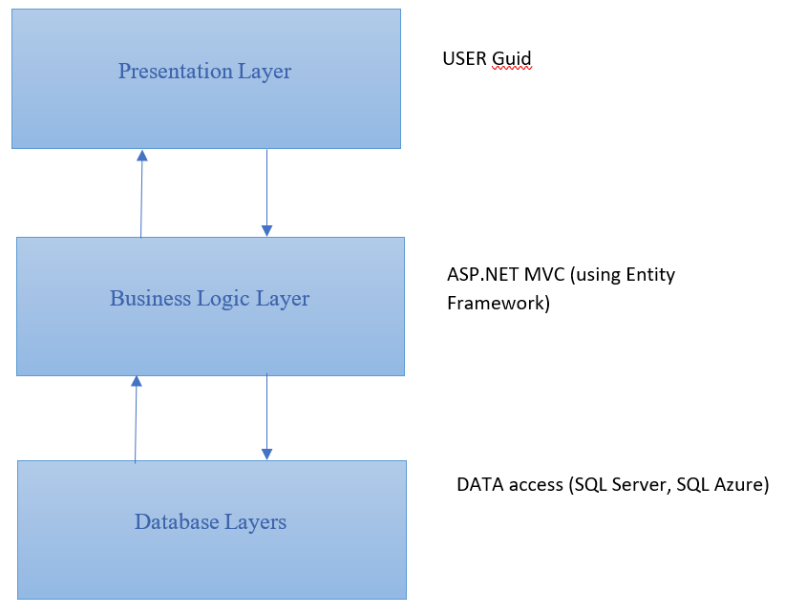

***Web-Based Distributed 3-Layer Architecture of the Project***

1. **Data Flow Diagrams (DFD)**

***(Form No. 5/eProjects/PS/Ver1.0)***

* 1. **Context diagram: DFD Level 1**
  2. **DFD Level 1**



* 1. **DFD Level 2.1**



* 1. **DFD Level 2.2**



* 1. **DFD Level 2.3**
  2. **DFD Level 2.4**





* 1. **DFD Level 2.5**
  2. **DFD Level 2.6**



* 1. **DFD Level 2.7**

1. **Flow Charts**

***(Form No. 6/eProjects/PS/Ver1.0)***

## ***Create Account Admin***

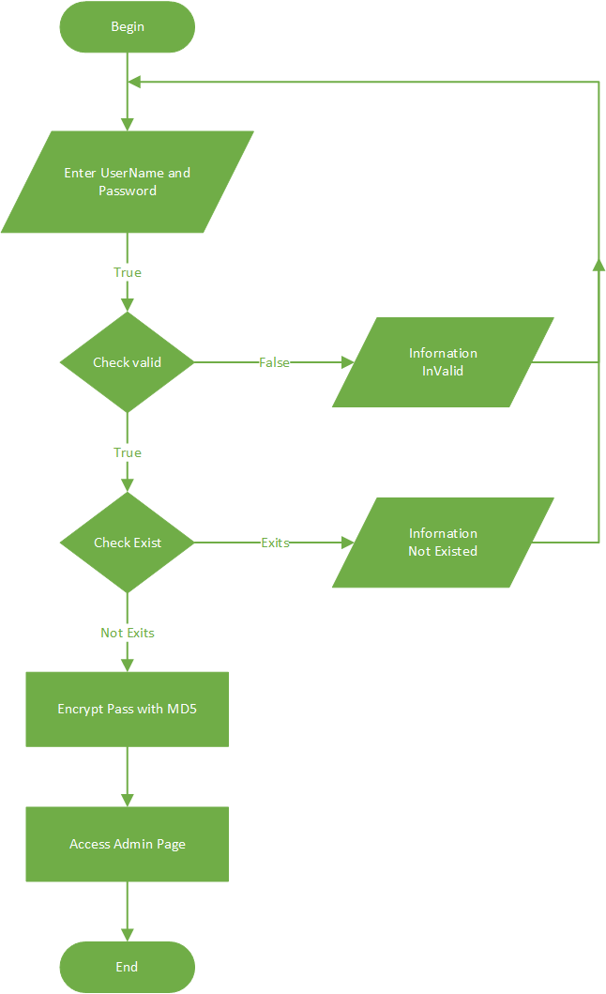

**Create Account Admin**

## ***Login Adminstrator***



**Login Admin Page**

## ***Insert: Restaurants, Hotels, Foods, Vehicle, Rooms, Tourist Spot, Transportation***



## ***Update: Restaurants, Hotels, Foods, Vehicle, Rooms, Tourist Spot, Transportation***

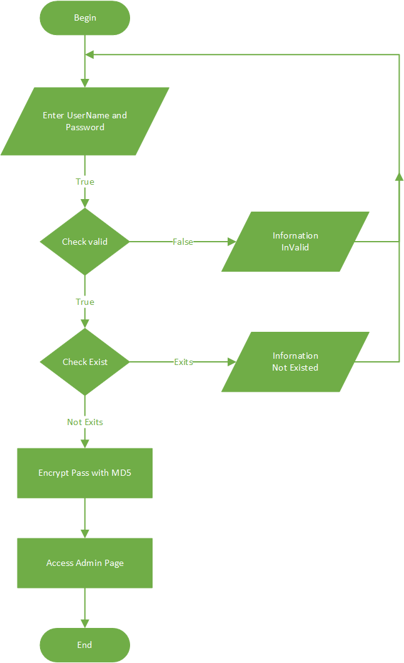

## ***Delete: Restaurants, Hotels, Foods, Vehicle, Rooms, Tourist Spot, Transportation***

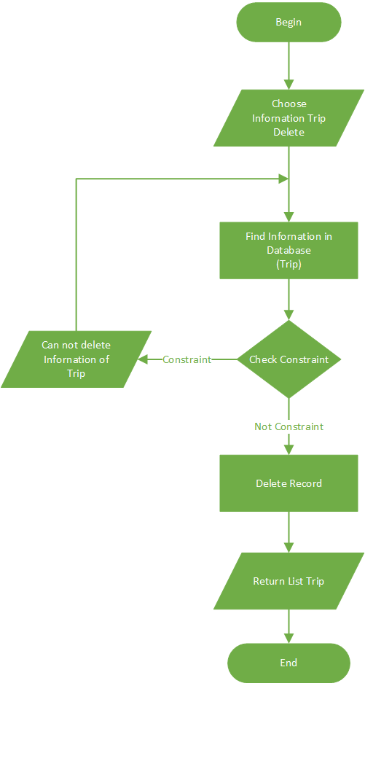

## ***Search***

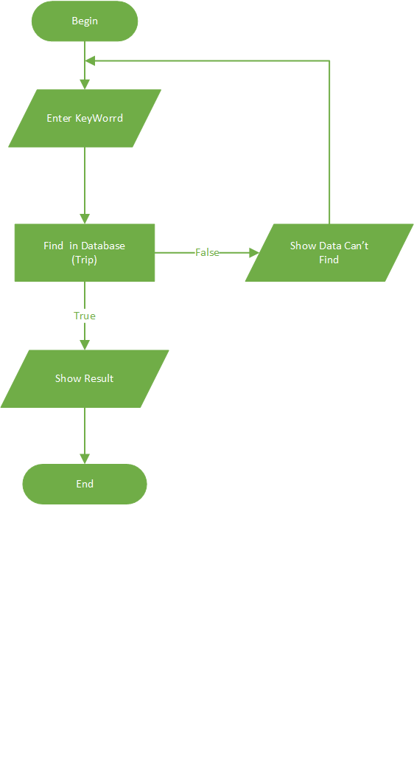

## ***Book Travel (Cart)***

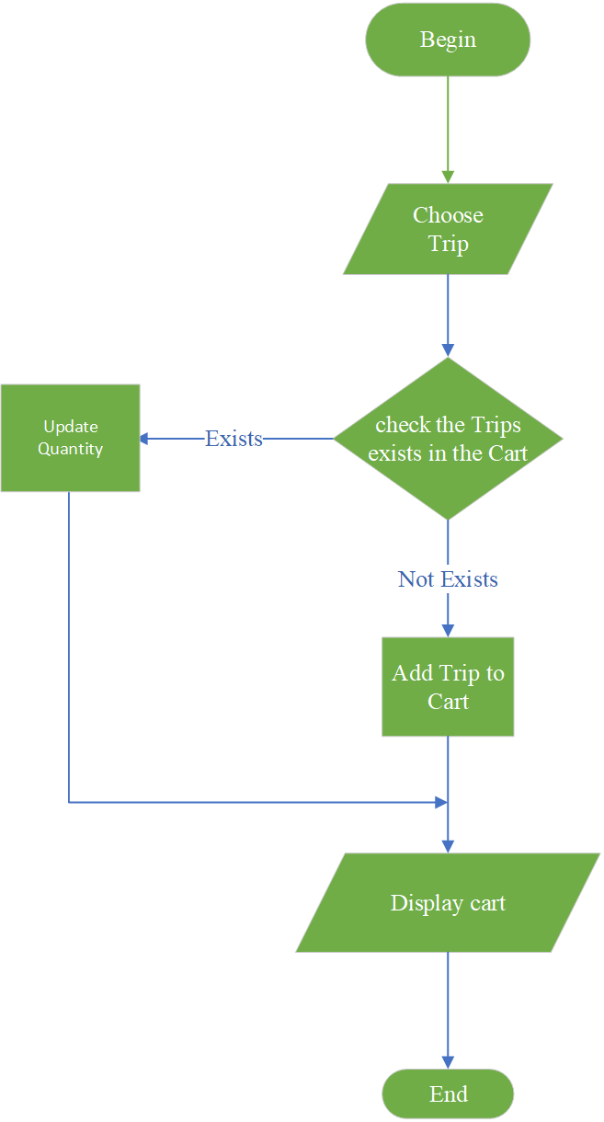

## **Check out Book travel**

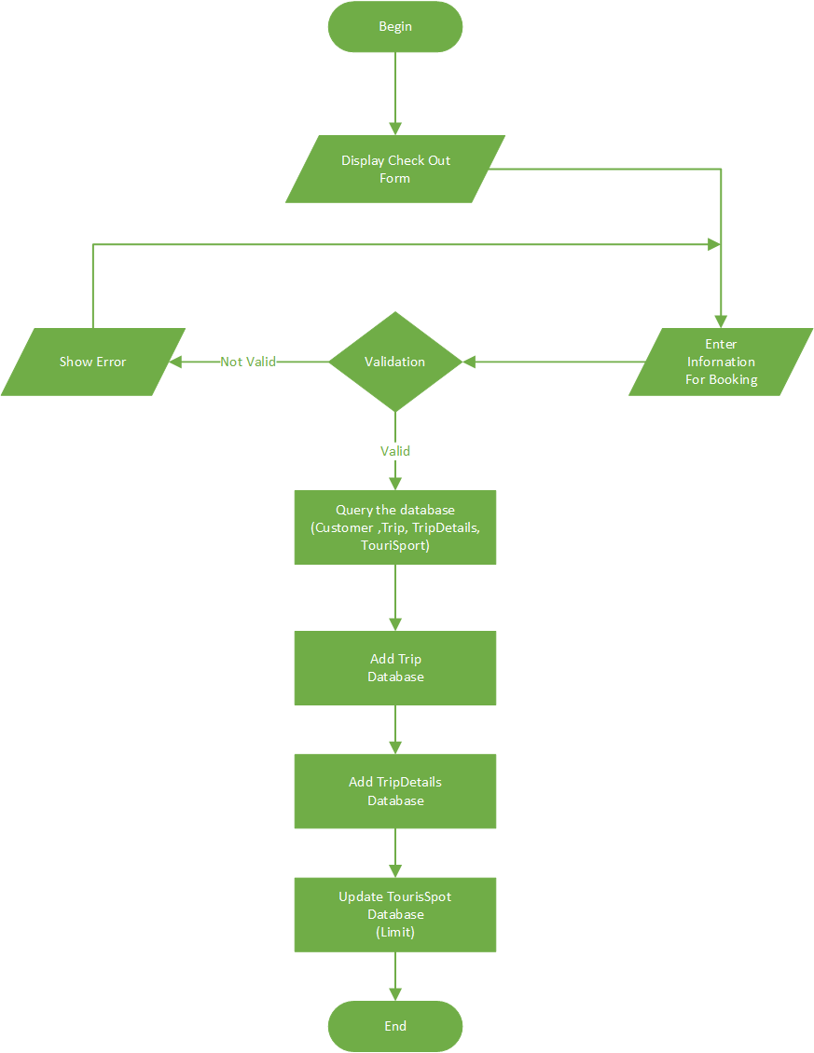

1. **Entity Relationship Diagrams**

***(Form No. 8/eProjects/PS/Ver1.0)***



2. **Data modeling (SQL SERVER)**

***(Form No. 9/eProjects/PS/Ver1.0)***



1. **Data Dictionary**

***(Form No. 10/eProjects/PS/Ver1.0)***

## ***Admin***

|  |  |  |  |  |
| --- | --- | --- | --- | --- |
| **Table: Admin** | | | | |
| **Fields** | **Data Type** | **Allow Nulls** | **Key** | **Description** |
| Username | nvarchar(20) | Not Nulls | Primary Key | Store the username of Administrator |
| Password | nvarchar(32) | Not Nulls |  | Store the password |

## ***Customer***

|  |  |  |  |  |
| --- | --- | --- | --- | --- |
| **Table: Customer** | | | | |
| **Fields** | **Data Type** | **Allow Nulls** | **Key** | **Description** |
| Customer_Id | nvarchar(20) | Not Nulls | Primary Key |  |
| Customer_Password | nvarchar(32) | Nulls |  |  |
| Customer_LastName | nvarchar(20) | Nulls |  |  |
| Customer_FirstName | nvarchar(20) | Nulls |  |  |
| Customer_Bithday | date | Nulls |  |  |
| Customer_Gender | bit | Nulls |  |  |
| Customer_Phone | nvarchar(20) | Nulls |  |  |
| Customer_Address | ntext | Nulls |  |  |
| Customer_Email | nvarchar(50) | Nulls |  |  |
| Customer_Possport | nvarchar(20) | Nulls |  |  |

## ***TripDetails***

|  |  |  |  |  |
| --- | --- | --- | --- | --- |
| **Table:TripDetails** | | | | |
| **Fields** | **Data Type** | **Allow Nulls** | **Key** | **Description** |
| Trip_Id | nvarchar(20) | Not Nulls | Primary Key, Foreign key |  |
| TouristSpot_Id | nvarchar(20) | Not Nulls | Primary Key, Foreign key |  |
| Trip_Quantity | int | Nulls |  |  |
| OrginalPrice | decimal(18, 0) | Nulls |  |  |

## ***ImgFoods***

|  |  |  |  |  |
| --- | --- | --- | --- | --- |
| **Table: ImgFoods** | | | | |
| **Fields** | **Data Type** | **Allow Nulls** | **Key** | **Description** |
| Img_Foods_Id | int | Not Nulls | Primary Key |  |
| Img_Foods | nvarchar(Max) | Nulls |  |  |
| Img_Foods_Sort | tinyint | Not Nulls |  |  |
| Food_code | nvarchar(20) | Nulls | Foreign key |  |

## ***Feedback***

|  |  |  |  |  |
| --- | --- | --- | --- | --- |
| **Table: Feedback** | | | | |
| **Fields** | **Data Type** | **Allow Nulls** | **Key** | **Description** |
| FeedbackId | int | Not Nulls | Primary Key |  |
| SenderName | nvarchar(50) | Nulls |  |  |
| SenderMail | nvarchar(50) | Nulls |  |  |
| FeedBackTitle | nvarchar(40) | Nulls |  |  |
| FeedBackContent | nvarchar(150) | Nulls |  |  |
| State | bit | Not Nulls |  |  |
| Create_on | datetime | Not Nulls |  |  |

## ***Foods***

|  |  |  |  |  |
| --- | --- | --- | --- | --- |
| **Table: Foods** | | | | |
| **Fields** | **Data Type** | **Allow Nulls** | **Key** | **Description** |
| Food_code | nvarchar(20) | Not Nulls | Primary Key |  |
| Food_Name | nvarchar(20) | Nulls |  |  |
| Food_Price | decimal(12,2) | Nulls |  |  |
| Food_Specific | ntext | Nulls |  |  |
| Restaurant_Code | nvarchar(20) | Nulls | Foreign key |  |

## ***ImgRestaurants***

|  |  |  |  |  |
| --- | --- | --- | --- | --- |
| **Table: ImgRestaurants** | | | | |
| **Fields** | **Data Type** | **Allow Nulls** | **Key** | **Description** |
| Img_Restaurants_Id | int | Not Nulls | Primary Key |  |
| Img_Restaurants | nvarchar(max) | Nulls |  |  |
| Img_Restaurants_Sort | tinyint | Not Nulls |  |  |
| Restaurant_Code | nvarchar(20) | Nulls | Foreign key |  |

## ***Restaurants***

|  |  |  |  |  |
| --- | --- | --- | --- | --- |
| **Table: Restaurants** | | | | |
| **Fields** | **Data Type** | **Allow Nulls** | **Key** | **Description** |
| Restaurant_Code | nvarchar(20) | Not Nulls | Primary Key |  |
| Restaurant_Name | nvarchar(20) | Nulls |  |  |
| Restaurant_Address | nvarchar(150) | Nulls |  |  |
| Restaurant_Status | bit | Nulls |  |  |
| Restaurant_Description | ntext | Nulls |  |  |
| TourisSpot_Id | nvarchar(20) | Nulls | Foreign key |  |
| Restaurant_Create | date | Nulls |  |  |

## ***ImgRoom***

|  |  |  |  |  |
| --- | --- | --- | --- | --- |
| **Table: ImgRoom** | | | | |
| **Fields** | **Data Type** | **Allow Nulls** | **Key** | **Description** |
| Img_Rooms_Id | int | Not Nulls | Primary Key |  |
| Img_Rooms | nvarchar(max) | Nulls |  |  |
| Img_Rooms_Sort | tinyint | Not Nulls |  |  |
| Room_Id | nvarchar(20) | Nulls | Foreign key |  |

## ***Room***

|  |  |  |  |  |
| --- | --- | --- | --- | --- |
| **Table: Room** | | | | |
| **Fields** | **Data Type** | **Allow Nulls** | **Key** | **Description** |
| Room_Id | nvarchar(20) | Not Nulls | Primary Key |  |
| Room_Type | nvarchar(20) | Nulls |  |  |
| Room_Name | nvarchar(20) | Nulls |  |  |
| Room_Start | time(7) | Nulls |  |  |
| Room_Stop | time(7) | Nulls |  |  |
| Room_Cost | money | Nulls |  |  |
| Hotel_Id | nvarchar(20) | Nulls | Foreign key |  |

## ***ImgHotel***

|  |  |  |  |  |
| --- | --- | --- | --- | --- |
| **Table: ImgHotel** | | | | |
| **Fields** | **Data Type** | **Allow Nulls** | **Key** | **Description** |
| Img_Hotels_Id | int | Not Nulls | Primary Key |  |
| Img_Hotels | nvarchar(Max) | Nulls |  |  |
| Img_Hotels_Sort | tinyint | Not Nulls |  |  |
| Hotel_Id | nvarchar(20) | Nulls | Foreign key |  |

## ***Hotel***

|  |  |  |  |  |
| --- | --- | --- | --- | --- |
| **Table: Hotel** | | | | |
| **Fields** | **Data Type** | **Allow Nulls** | **Key** | **Description** |
| Hotel_Id | nvarchar(20) | Not Nulls | Primary Key |  |
| Hotel_Name | nvarchar(120) | Nulls |  |  |
| Hotel_Address | nvarchar(255) | Nulls |  |  |
| Hotel_Status | bit | Nulls |  |  |
| Hotel_Detail | nvarchar(Max) | Nulls |  |  |
| TourisSpot_id | nvarchar(20) | Nulls | Foreign key |  |
| Hotel_Create | date | Nulls |  |  |

## ***Transportations***

|  |  |  |  |  |
| --- | --- | --- | --- | --- |
| **Table: Transportations** | | | | |
| **Fields** | **Data Type** | **Allow Nulls** | **Key** | **Description** |
| Transportations_Id | nvarchar(20) | Not Nulls | Primary Key |  |
| Transportations_Name | nvarchar(100) | Not Nulls |  |  |
| Transportations_Detail | nvarchar(255) | Nulls |  |  |
| Transportations_Img | nvarchar(150) | Nulls |  |  |
| TourisSpot_id | nvarchar(20) | Nulls | Foreign key |  |
| Transportation_Create | date | Nulls |  |  |

## ***Abouts***

|  |  |  |  |  |
| --- | --- | --- | --- | --- |
| **Table: Abouts** | | | | |
| **Fields** | **Data Type** | **Allow Nulls** | **Key** | **Description** |
| AboutId | int | Not Nulls | Primary Key |  |
| AboutName | nvarchar(50) | Nulls |  |  |
| AboutBirth | date | Nulls |  |  |
| AboutGender | bit | Nulls |  |  |
| AboutLike | nvarchar(150) | Nulls |  |  |
| AboutImg | nvarchar(250) | Nulls |  |  |

## ***Vehicle***

|  |  |  |  |  |
| --- | --- | --- | --- | --- |
| **Table: Vehicle** | | | | |
| **Fields** | **Data Type** | **Allow Nulls** | **Key** | **Description** |
| Vehicle_Id | nvarchar(20) | Not Nulls | Primary Key |  |
| Vehicle_Name | nvarchar(25) | Nulls |  |  |
| Vehicle_Price | decimal(12, 0) | Nulls |  |  |
| Vehicle_Weight | int | Nulls |  |  |
| Vehicle_Img | nvarchar(50) | Nulls |  |  |
| Transportations_Id | nvarchar(20) | Nulls | Foreign key |  |
| Vehicle_Create | date | Nulls |  |  |

## ***Trip***

|  |  |  |  |  |
| --- | --- | --- | --- | --- |
| **Table: Trip** | | | | |
| **Fields** | **Data Type** | **Allow Nulls** | **Key** | **Description** |
| Trip_Id | nvarchar(20) | Not Nulls | Primary Key |  |
| Trip_Name | nvarchar(25) | Not Nulls |  |  |
| Trip_Detail | ntext | Nulls |  |  |
| Trip_Date | datetime | Nulls |  |  |
| Trip_Address | ntext | Nulls |  |  |
| Trip_Status | bit | Nulls |  |  |
| Customer_Id | nvarchar(20) | Nulls | Foreign key |  |
| PaymentId | int | Nulls |  |  |
| MasterOnline | nvarchar(50) | Nulls |  |  |

## ***Location***

|  |  |  |  |  |
| --- | --- | --- | --- | --- |
| **Table: Location** | | | | |
| **Fields** | **Data Type** | **Allow Nulls** | **Key** | **Description** |
| Location_Id | nvarchar(20) | Not Nulls | Primary Key |  |
| Location_Name | nvarchar(20) | Nulls |  |  |
| Location_Location | nvarchar(20) | Nulls |  |  |

## ***ImgTouristSpot***

|  |  |  |  |  |
| --- | --- | --- | --- | --- |
| **Table: Img_TouristSpot** | | | | |
| **Fields** | **Data Type** | **Allow Nulls** | **Key** | **Description** |
| Img_TouristSpot_Id | int | Not Nulls | Primary Key |  |
| Img_TouristSpot | nvarchar(MAX) | Not Nulls | Primary Key |  |
| Img_TouristSpot_Sort | tinyint |  |  |  |
| TouristSpot_Id | nvarchar(20) |  | Foreign key |  |

## ***TouristSpot***

|  |  |  |  |  |
| --- | --- | --- | --- | --- |
| **Table: TouristSpot** | | | | |
| **Fields** | **Data Type** | **Allow Nulls** | **Key** | **Description** |
| TouristSpot_Id | nvarchar(20) | Not Nulls |  |  |
| TouristSpot_Name | nvarchar(30) | Nulls |  |  |
| TouristSpot_Limit | int | Nulls |  |  |
| TouristSpot_Price | decimal(12, 0) | Nulls |  |  |
| TouristSpot_Specific | nvarchar(20) | Nulls |  |  |
| TouristSpot_Status | bit | Nulls |  |  |
| TouristSpot_Img | nvarchar(50) | Nulls |  |  |
| Localtion_Id | nvarchar(20) | Nulls | Foreign key |  |
| TouristSpot_Create | date | Nulls |  |  |

## ***PaymentMethod***

|  |  |  |  |  |
| --- | --- | --- | --- | --- |
| **Table: PaymentMethos** | | | | |
| **Fields** | **Data Type** | **Allow Nulls** | **Key** | **Description** |
| PaymentId | int | Not Nulls |  |  |
| PaymentName | varchar (50) | Nulls |  |  |

1. **Site Map**

***(Form No. 11/eProjects/PS/Ver1.0)***

## Admin

## User

1. **Task Sheet**

***(Form No. 12/eProjects/PS/Ver1.0)***

|  |  |  |  |  |  |  |  |  |
| --- | --- | --- | --- | --- | --- | --- | --- | --- |
| **Project Ref. No: 1**  **Ep/Advertisement Portal Management System/01** | | **Project Titles:**  **Karnel Travel** | **Activity Plan Prepared By:**  **Huy Dang Tuan** | **Date of Preparation of Activity Plan:**  Project Start Date: 11-Sept-2018 | | | | |
| **Sr.No** | **Task** | **Document (KarnelTravel.docx)** | Student1058384 HUY DANG TUAN  Student1007818 SON PHAM NGUYEN HOANG  Student1111738 PHONG TRAN TRUNG | **Actual Start Date** | **Actual Days** | **Team Mate Names** | **Status** | **Total Status** |
| 1 | **PROBLEM DEFINITION** | 11-Sep-2018 | 12-Sep-2018 | Student1058384 HUY DANG TUAN  Student1007818 SON PHAM NGUYEN HOANG  Student1111738 PHONG TRAN TRUNG | 100% | Complete |
| **CRS** | 11-Sep-2018 | 14-Sep-2018 | 100% | Complete |
| **ARCHITECTURE & DESIGN OF THE PROJECT** | 11-Sep-2018 | 16-Sep-2018 | 100% | Complete |
| **SITE MAP** | 11-Sep-2018 | 18-Sep-2018 | 100% | Complete |
| **INPUTS, OUTPUTS, PROCESS** | 11-Sep-2018 | 20-Sep-2018 | 100% | Complete |
| **FLOWCHART** | 11-Sep-2018 | 16-Sep-2018 | 100% | Complete |
| **DFD** | 11-Sep-2018 | 13-Sep-2018 | 100% | Complete |
| **E-R DIAGRAMS** | 11-Sep-2018 | 18-Sep-2018 | 100% | Complete |
| 2 | **Design Database** | **Using Visio** | Student1058384 HUY DANG TUAN  Student1007818 SON PHAM NGUYEN HOANG  Student1111738 PHONG TRAN TRUNG | 11-Sep-2018 | 14-Sep-2018 | Student1058384 HUY DANG TUAN  Student1007818 SON PHAM NGUYEN HOANG  Student1111738 PHONG TRAN TRUNG | 100% | Complete |
| **Publish Database** | **Using Window Azure and SQL Server 2014** | Student1058384 HUY DANG TUAN  Student1007818 SON PHAM NGUYEN HOANG  Student1111738 PHONG TRAN TRUNG | 11-Sep-2018 | 16-Sep-2018 | Student1058384 HUY DANG TUAN  Student1007818 SON PHAM NGUYEN HOANG  Student1111738 PHONG TRAN TRUNG | 100% | Complete |
| 3 | **Design template Admin** | **Using Visual Studio 2017, Bootstrap** | Student1058384 HUY DANG TUAN  Student1007818 SON PHAM NGUYEN HOANG  Student1111738 PHONG TRAN TRUNG | 14-Sep-2018 | 19-Sep-2018 | Student1058384 HUY DANG TUAN  Student1007818 SON PHAM NGUYEN HOANG  Student1111738 PHONG TRAN TRUNG | 100% | Complete |
| 4 | **Design template User** | **Using Visual Studio 2017, Bootstrap** | Student1058384 HUY DANG TUAN  Student1007818 SON PHAM NGUYEN HOANG  Student1111738 PHONG TRAN TRUNG  Student989084 NHI NGUYEN THI YEN | 14-Sep-2018 | 19-Sep-2018 | Student1058384 HUY DANG TUAN  Student1007818 SON PHAM NGUYEN HOANG  Student1111738 PHONG TRAN TRUNG  Student989084 NHI NGUYEN THI YEN | 100% | Complete |
| 5 | **Login** | **Using template Admin** | Student1058384 HUY DANG TUAN  Student1007818 SON PHAM NGUYEN HOANG  Student1111738 PHONG TRAN TRUNG | 19-Sep-2018 | 24-Sep-2018 | Student1058384 HUY DANG TUAN  Student1007818 SON PHAM NGUYEN HOANG  Student1111738 PHONG TRAN TRUNG | 100% | Complete |
| 6 | **Management Location** | **Using template Admin** | Student1058384 HUY DANG TUAN  Student1007818 SON PHAM NGUYEN HOANG  Student1111738 PHONG TRAN TRUNG | 19-Sep-2018 | 24-Sep-2018 | Student1058384 HUY DANG TUAN  Student1007818 SON PHAM NGUYEN HOANG  Student1111738 PHONG TRAN TRUNG | 100% | Complete |
| 7 | **Management Details About US** | **Using template Admin** | Student1058384 HUY DANG TUAN  Student1007818 SON PHAM NGUYEN HOANG  Student1111738 PHONG TRAN TRUNG | 19-Sep-2018 | 24-Sep-2018 | Student1058384 HUY DANG TUAN  Student1007818 SON PHAM NGUYEN HOANG  Student1111738 PHONG TRAN TRUNG | 100% | Complete |
| 8 | **Management Vehicle** | **Using template Admin** | Student1058384 HUY DANG TUAN  Student1007818 SON PHAM NGUYEN HOANG  Student1111738 PHONG TRAN TRUNG | 19-Sep-2018 | 24-Sep-2018 | Student1058384 HUY DANG TUAN  Student1007818 SON PHAM NGUYEN HOANG  Student1111738 PHONG TRAN TRUNG | 100% | Complete |
| 9 | **Management Restaurants** | **Using template Admin** | Student1058384 HUY DANG TUAN  Student1007818 SON PHAM NGUYEN HOANG  Student1111738 PHONG TRAN TRUNG | 19-Sep-2018 | 24-Sep-2018 | Student1058384 HUY DANG TUAN  Student1007818 SON PHAM NGUYEN HOANG  Student1111738 PHONG TRAN TRUNG | 100% | Complete |
| 10 | **Management Rooms** | **Using template Admin** | Student1058384 HUY DANG TUAN  Student1007818 SON PHAM NGUYEN HOANG  Student1111738 PHONG TRAN TRUNG | 19-Sep-2018 | 24-Sep-2018 | Student1058384 HUY DANG TUAN  Student1007818 SON PHAM NGUYEN HOANG  Student1111738 PHONG TRAN TRUNG | 100% | Complete |
| 11 | **Management Tourist Spot** | **Using template Admin** | Student1058384 HUY DANG TUAN  Student1007818 SON PHAM NGUYEN HOANG  Student1111738 PHONG TRAN TRUNG | 19-Sep-2018 | 24-Sep-2018 | Student1058384 HUY DANG TUAN  Student1007818 SON PHAM NGUYEN HOANG  Student1111738 PHONG TRAN TRUNG |  |  |
| 12 | **Management Transportations** | **Using template Admin** | Student1058384 HUY DANG TUAN  Student1007818 SON PHAM NGUYEN HOANG  Student1111738 PHONG TRAN TRUNG | 19-Sep-2018 | 24-Sep-2018 | Student1058384 HUY DANG TUAN  Student1007818 SON PHAM NGUYEN HOANG  Student1111738 PHONG TRAN TRUNG | 100% | Complete |
| 13 | **Management Foods** | **Using template Admin** | Student989084 NHI NGUYEN THI YEN | 19-Sep-2018 | 24-Sep-2018 | Student989084 NHI NGUYEN THI YEN | 100% | Complete |
| 14 | **Management Hotels** | **Using template Admin** | Student1058384 HUY DANG TUAN  Student1007818 SON PHAM NGUYEN HOANG  Student1111738 PHONG TRAN TRUNG  Student989084 NHI NGUYEN THI YEN | 19-Sep-2018 | 24-Sep-2018 | Student1058384 HUY DANG TUAN  Student1007818 SON PHAM NGUYEN HOANG  Student1111738 PHONG TRAN TRUNG Student989084 NHI NGUYEN THI YEN | 100% | Complete |
| 15 | **Management Customer** | **Using template Admin** | Student1058384 HUY DANG TUAN  Student1007818 SON PHAM NGUYEN HOANG  Student1111738 PHONG TRAN TRUNG | 19-Sep-2018 | 24-Sep-2018 |  |  |  |
| 16 | **Management Payment Method** | **Using template Admin** | Student1058384 HUY DANG TUAN  Student1007818 SON PHAM NGUYEN HOANG  Student1111738 PHONG TRAN TRUNG | 19-Sep-2018 | 24-Sep-2018 | Student1058384 HUY DANG TUAN  Student1007818 SON PHAM NGUYEN HOANG  Student1111738 PHONG TRAN TRUNG | 60% | Not Complete |
| 17 | **Statistics** | **Using template Admin** | Student1058384 HUY DANG TUAN  Student1007818 SON PHAM NGUYEN HOANG  Student1111738 PHONG TRAN TRUNG | 19-Sep-2018 | 24-Sep-2018 | Student1058384 HUY DANG TUAN  Student1007818 SON PHAM NGUYEN HOANG  Student1111738 PHONG TRAN TRUNG | 100% | Complete |
| 18 | **Home Page** | **User Layout** | Student1058384 HUY DANG TUAN  Student1007818 SON PHAM NGUYEN HOANG  Student1111738 PHONG TRAN TRUNG | 19-Sep-2018 | 27-Sep-2018 | Student1058384 HUY DANG TUAN  Student1007818 SON PHAM NGUYEN HOANG  Student1111738 PHONG TRAN TRUNG | 100% | Complete |
| 19 | **Restaurant Page** | **User Layout** | Student1058384 HUY DANG TUAN  Student1007818 SON PHAM NGUYEN HOANG  Student1111738 PHONG TRAN TRUNG | 19-Sep-2018 | 27-Sep-2018 | Student1058384 HUY DANG TUAN  Student1007818 SON PHAM NGUYEN HOANG  Student1111738 PHONG TRAN TRUNG | 100% | Complete |
| 20 | **Hotels Page** | **User Layout** | Student1058384 HUY DANG TUAN  Student1007818 SON PHAM NGUYEN HOANG  Student1111738 PHONG TRAN TRUNG | 19-Sep-2018 | 27-Sep-2018 | Student1058384 HUY DANG TUAN  Student1007818 SON PHAM NGUYEN HOANG  Student1111738 PHONG TRAN TRUNG | 100% | Complete |
| 21 | **Contacts Page** | **User Layout** | Student1058384 HUY DANG TUAN  Student1007818 SON PHAM NGUYEN HOANG  Student1111738 PHONG TRAN TRUNG | 19-Sep-2018 | 27-Sep-2018 | Student1058384 HUY DANG TUAN  Student1007818 SON PHAM NGUYEN HOANG  Student1111738 PHONG TRAN TRUNG | 100% | Complete |
| 22 | **About US Page** | **User Layout** | Student1058384 HUY DANG TUAN  Student1007818 SON PHAM NGUYEN HOANG  Student1111738 PHONG TRAN TRUNG | 19-Sep-2018 | 27-Sep-2018 | Student1058384 HUY DANG TUAN  Student1007818 SON PHAM NGUYEN HOANG  Student1111738 PHONG TRAN TRUNG | 100% | Complete |
| 23 | **Tourist Spot Page** | **User Layout** | Student1058384 HUY DANG TUAN  Student1007818 SON PHAM NGUYEN HOANG  Student1111738 PHONG TRAN TRUNG | 19-Sep-2018 | 27-Sep-2018 | Student1058384 HUY DANG TUAN  Student1007818 SON PHAM NGUYEN HOANG  Student1111738 PHONG TRAN TRUNG | 100% | Complete |
| 24 | **Vehicle Page** | **User Layout** | Student1058384 HUY DANG TUAN  Student1007818 SON PHAM NGUYEN HOANG  Student1111738 PHONG TRAN TRUNG | 19-Sep-2018 | 27-Sep-2018 | Student1058384 HUY DANG TUAN  Student1007818 SON PHAM NGUYEN HOANG  Student1111738 PHONG TRAN TRUNG | 100% | Complete |
| 25 | **Transportation Page** | **User Layout** | Student1058384 HUY DANG TUAN  Student1007818 SON PHAM NGUYEN HOANG  Student1111738 PHONG TRAN TRUNG | 19-Sep-2018 | 27-Sep-2018 | Student1058384 HUY DANG TUAN  Student1007818 SON PHAM NGUYEN HOANG  Student1111738 PHONG TRAN TRUNG | 100% | Complete |
| 26 | **Search Page + Details (Restaurant, Hotels, Food, Tourist Spot** | **User Layout** | Student1058384 HUY DANG TUAN  Student1007818 SON PHAM NGUYEN HOANG  Student1111738 PHONG TRAN TRUNG | 19-Sep-2018 | 27-Sep-2018 | Student1058384 HUY DANG TUAN  Student1007818 SON PHAM NGUYEN HOANG  Student1111738 PHONG TRAN TRUNG | 100% | Complete |
| 27 | **Food Pages** | **User Layout** | Student1058384 HUY DANG TUAN  Student1007818 SON PHAM NGUYEN HOANG  Student1111738 PHONG TRAN TRUNG | 19-Sep-2018 | 27-Sep-2018 | Student1058384 HUY DANG TUAN  Student1007818 SON PHAM NGUYEN HOANG  Student1111738 PHONG TRAN TRUNG | 100% | Complete |
| 28 | **Room Pages** | **User Layout** | Student1058384 HUY DANG TUAN  Student1007818 SON PHAM NGUYEN HOANG  Student1111738 PHONG TRAN TRUNG | 19-Sep-2018 | 27-Sep-2018 | Student1058384 HUY DANG TUAN  Student1007818 SON PHAM NGUYEN HOANG  Student1111738 PHONG TRAN TRUNG | 100% | Complete |
| 29 | **Rate Tourist Spot** | **User Layout** | Student1058384 HUY DANG TUAN  Student1007818 SON PHAM NGUYEN HOANG  Student1111738 PHONG TRAN TRUNG | 27-Sep-2018 | 28-Sep-2018 | Student1058384 HUY DANG TUAN  Student1007818 SON PHAM NGUYEN HOANG  Student1111738 PHONG TRAN TRUNG | 0% | Not Complete |
| 30 | **Register** | **User Layout** | Student1058384 HUY DANG TUAN  Student1007818 SON PHAM NGUYEN HOANG  Student1111738 PHONG TRAN TRUNG | 27-Sep-2018 | 28-Sep-2018 | Student1058384 HUY DANG TUAN  Student1007818 SON PHAM NGUYEN HOANG  Student1111738 PHONG TRAN TRUNG | 100% | Complete |
| 31 | **Login** | **User Layout** | Student1058384  HUY DANG TUAN  Student1007818 SON PHAM NGUYEN HOANG  Student1111738 PHONG TRAN TRUNG | 27-Sep-2018 | 28-Sep-2018 | Student1058384 HUY DANG TUAN  Student1007818 SON PHAM NGUYEN HOANG  Student1111738 PHONG TRAN TRUNG | 100% | Complete |
| 32 | **Update Account of User** | **User Layout** | Student1058384  HUY DANG TUAN  Student1007818 SON PHAM NGUYEN HOANG  Student1111738 PHONG TRAN TRUNG | 27-Sep-2018 | 28-Sep-2018 | Student1058384  HUY DANG TUAN  Student1007818 SON PHAM NGUYEN HOANG  Student1111738 PHONG TRAN TRUNG | 100% | Complete |
| 33 | **Log Out** | **User Layout** | Student1058384 HUY DANG TUAN  Student1007818 SON PHAM NGUYEN HOANG  Student1111738 PHONG TRAN TRUNG | 27-Sep-2018 | 28-Sep-2018 | Student1058384 HUY DANG TUAN  Student1007818 SON PHAM NGUYEN HOANG  Student1111738 PHONG TRAN TRUNG | 100% | Complete |
| 34 | **Order Travel** | **User Layout** | Student1058384 HUY DANG TUAN  Student1007818 SON PHAM NGUYEN HOANG  Student1111738 PHONG TRAN TRUNG | 27-Sep-2018 | 28-Sep-2018 | Student1058384 HUY DANG TUAN  Student1007818 SON PHAM NGUYEN HOANG  Student1111738 PHONG TRAN TRUNG |  |  |
| 35 | **Fix Layout**  **(User Interface)** | **User Layout & Admin Layout** | Student989084 NHI NGUYEN THI YEN |  |  | Student989084 NHI NGUYEN THI YEN | 100% | Complete |
| 36 | **Publish Web** | **Using IIS or Window Azure** | Student989084 NHI NGUYEN THI YEN |  |  | Student989084 NHI NGUYEN THI YEN | 100% | Complete |
| 37 |  |  |  |  |  |  |  |  |

1. **Check list Validation**

***(Form No. 13/eProjects/PS/Ver1.0)***

|  |  |
| --- | --- |
| Option | Validated |
| Do all numeric variables have a default values or zeros? | Yes |
| Does the administrator have all the rights to create and delete record? | Yes |
| Are all the records properly fed into the appropriate database? | Yes |
| Have all the modules been properly integrated and are completely function? | Yes |
| Have all the design and coding standards been followed and implemented? | Yes |
| Is the design consistent all over? | Yes |
| Is the navigation sequence current through all the screens in the application? | Yes |
| Is exception handing mechanism implemented in all the screens? | Yes |
| Are all the programs codes working? | Yes |

1. **Submission Checklist**

***(Form No. 14/eProjects/PS/Ver1.0)***

|  |  |  |  |  |  |
| --- | --- | --- | --- | --- | --- |
| **Sr. No** | **Particulars** | **Yes** | **No** | **NA** | **Comments** |
| **1.** | Have all the modules been properly integrated and are they completely functional? | X |  |  |  |
| **2.** | Does each unit meet its objective and purpose?  Are all the validations happen as specified in Process Design? | X |  |  |  |
| **3.** | Have all Design and Coding standards been followed and implemented? | X |  |  |  |
| **4.** | Is GUI design consistent all over? | X |  |  | Includes admin page and the user page (Responsive web design) |
| **5.** | Are the codes working as per the specification? | X |  |  |  |
| **6.** | Does the application’s functionality resolve the client problem, and satisfy his/her needs completely? | X |  |  |  |
| **7.** | Have the Hardware and software been correctly chosen? | X |  |  |  |
| **8.** | Additional features and utilities that give values addition to the entire project | X |  |  | Using Captcha, Bootstraps, jQuery, Page List…. |

1. **User Guid and Install eProject**

***(Form No. 15/eProjects/PS/Ver1.0)***

## System Requirement:

|  |  |  |
| --- | --- | --- |
| No. | Items | Description |
| 1 | Operating System | Win 7, Win 8.1 or higher |
| 2 | Database | SQL 2012-2017 (using SQL 2014) |
| 3 | Software | Visual Studio 2017 Pro with Asp.Net MVC template |

## Install and Run App

13.2.1 SQL Server local (2014)

* Go to link: <https://www.microsoft.com/en-us/download/details.aspx?id=42299>
* Choose SQL
* 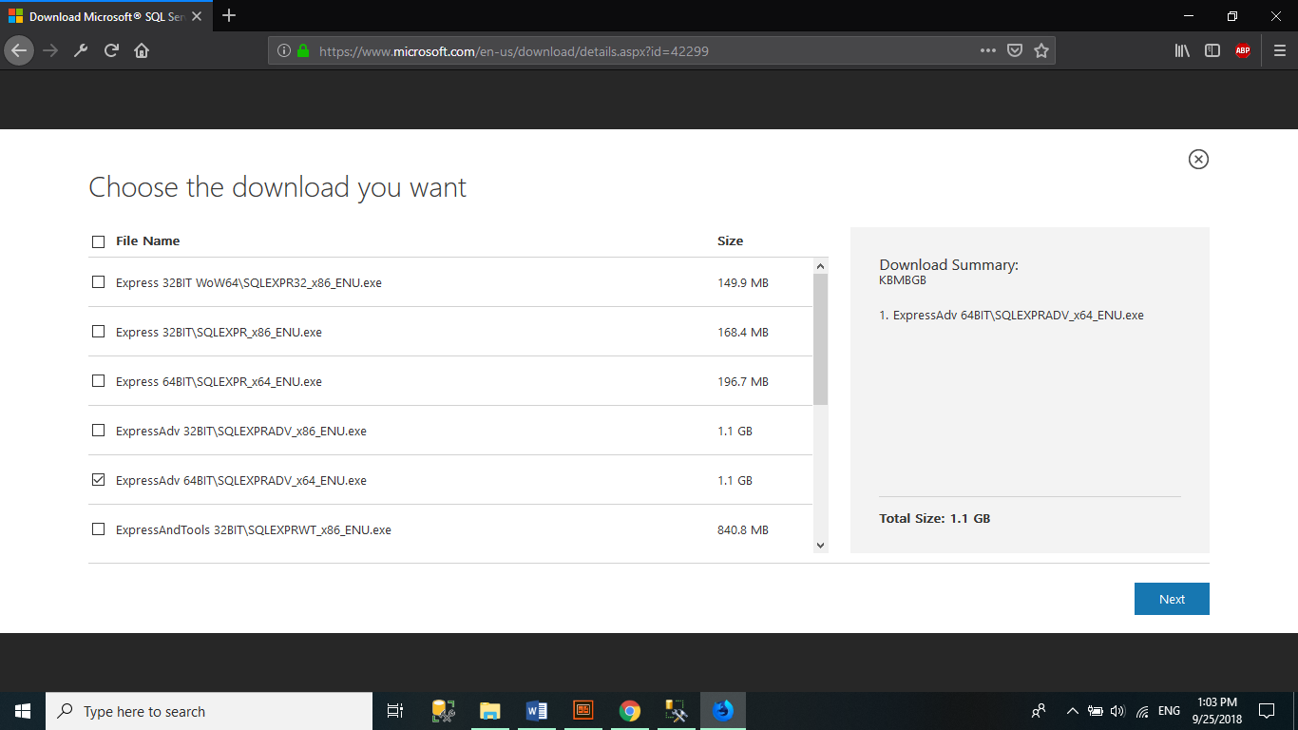Download

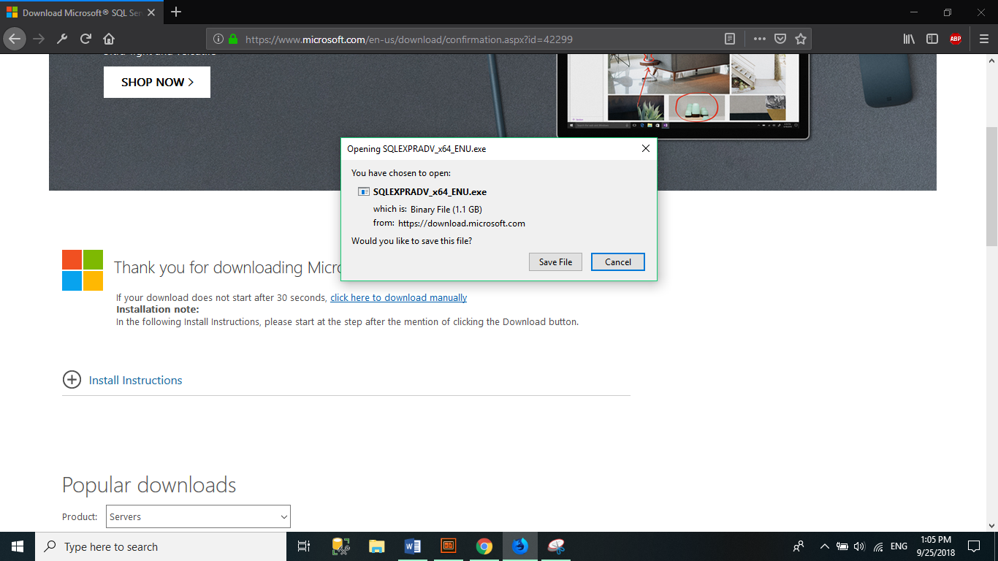

* Install step by step
* 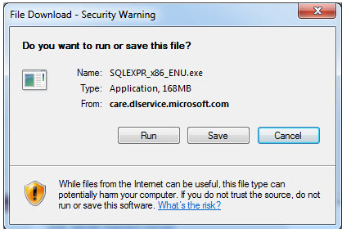**Step 1:** Click on the downloaded file and **Run** the file.
* 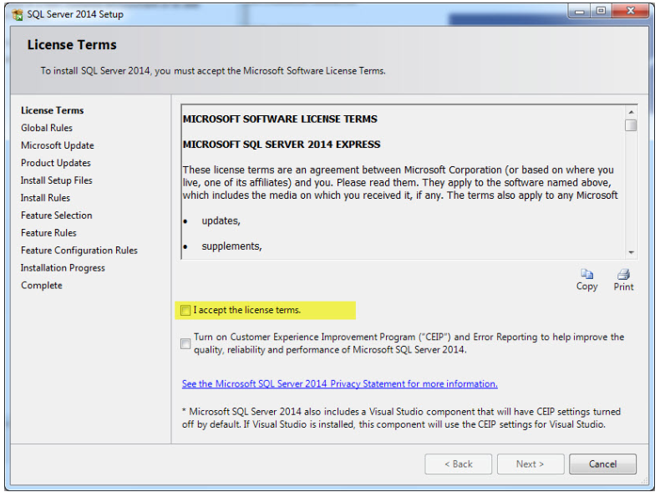**Step 2: Accept the license terms and click**Next**.**
* 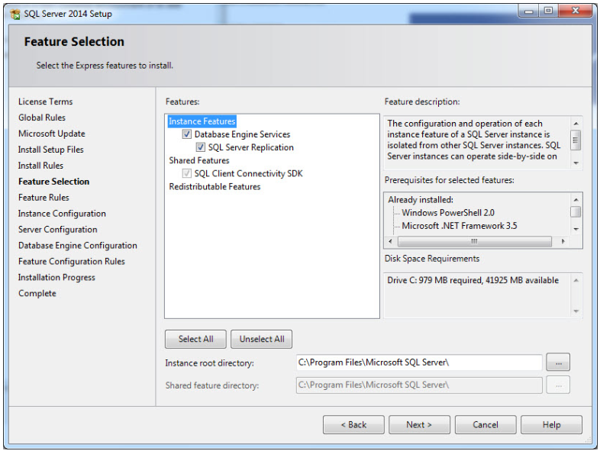**Step 3: On the Feature Selection screen, keep the defaults**
* **Step 4: On instance configuration screen, select “**Named Instance**” and name the database you want and click.**

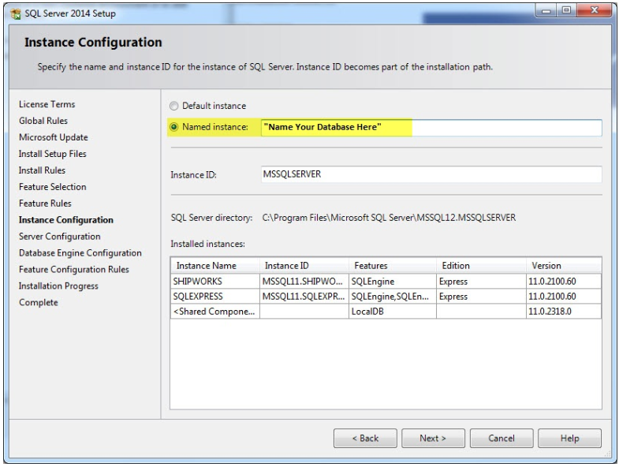

* 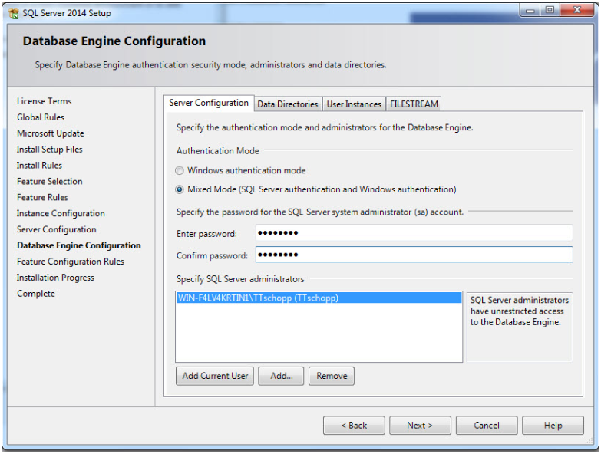**Step 5: Click**Next**until you get to the**Database Engine Configuration**screen and select**Mixed Mode. **Don’t forget to save login details and passwords in another document.**

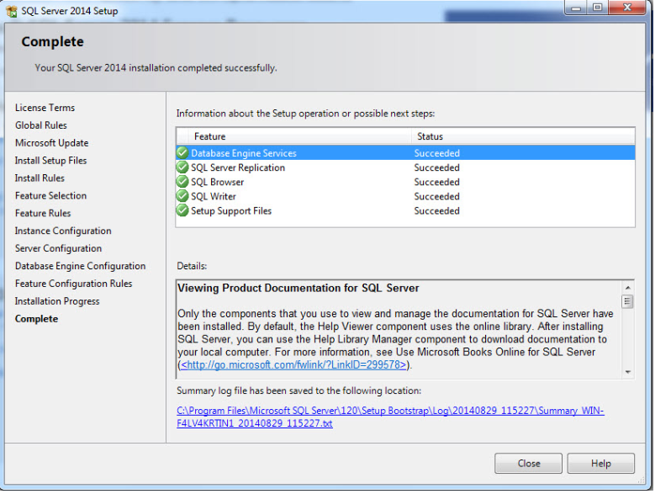**Step 6:** **Click**Next**until your setup is complete. Click**Close**.**

* 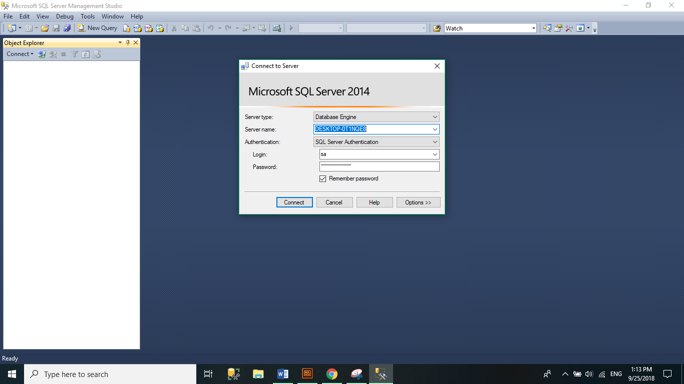**Result**

## GUI

13.3.1. Config SQL 2014 and VS 2017 Pro

13.3.2. Administrator

* Login with username: dangtuanhuy and password: dangtuanhuy
* 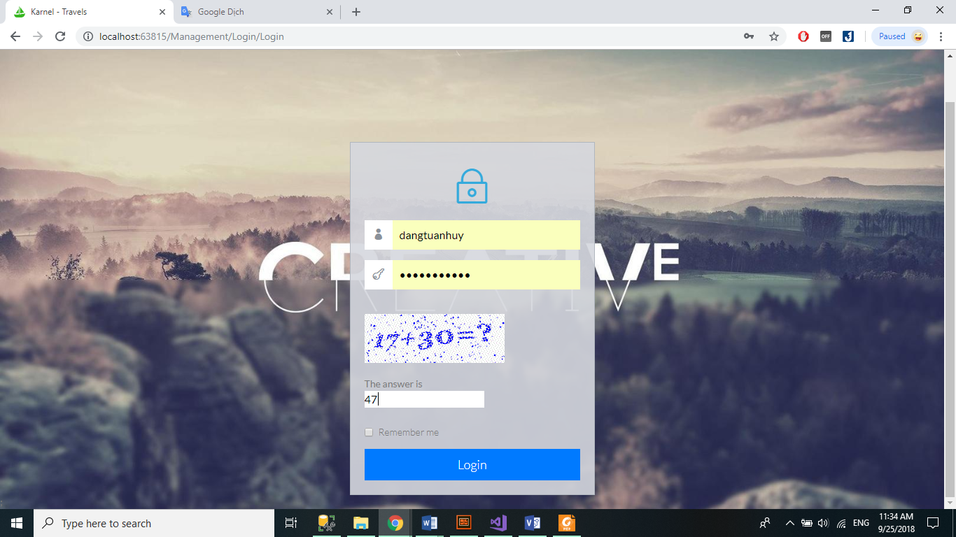Interface Admin Page Karnel Travel
* 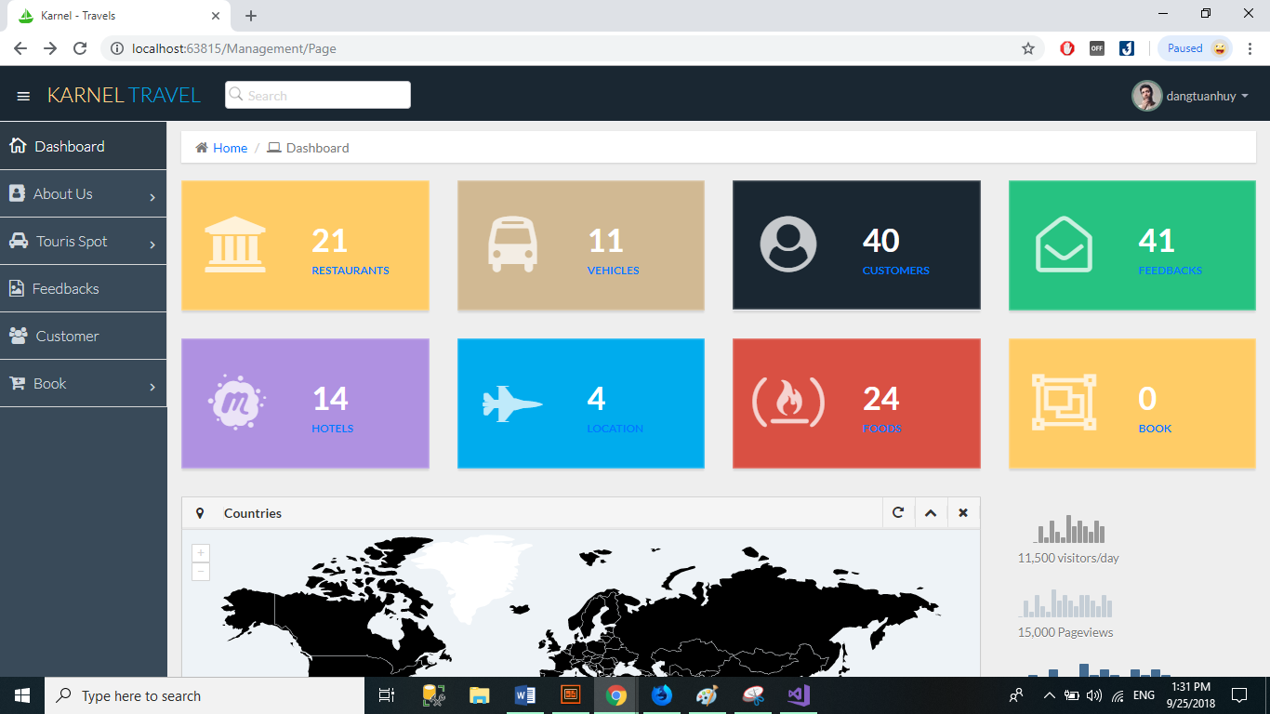Demo: List, Create, Edit, Delete, Upload Multiples File IMG (Hotel), upload Single file (Vehicle),
* 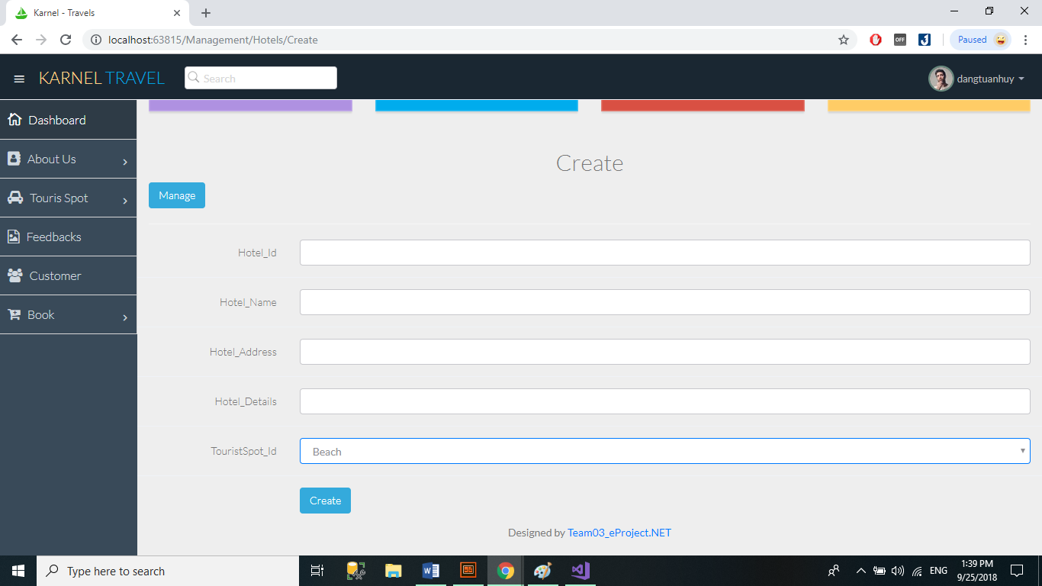Create Hotels
* 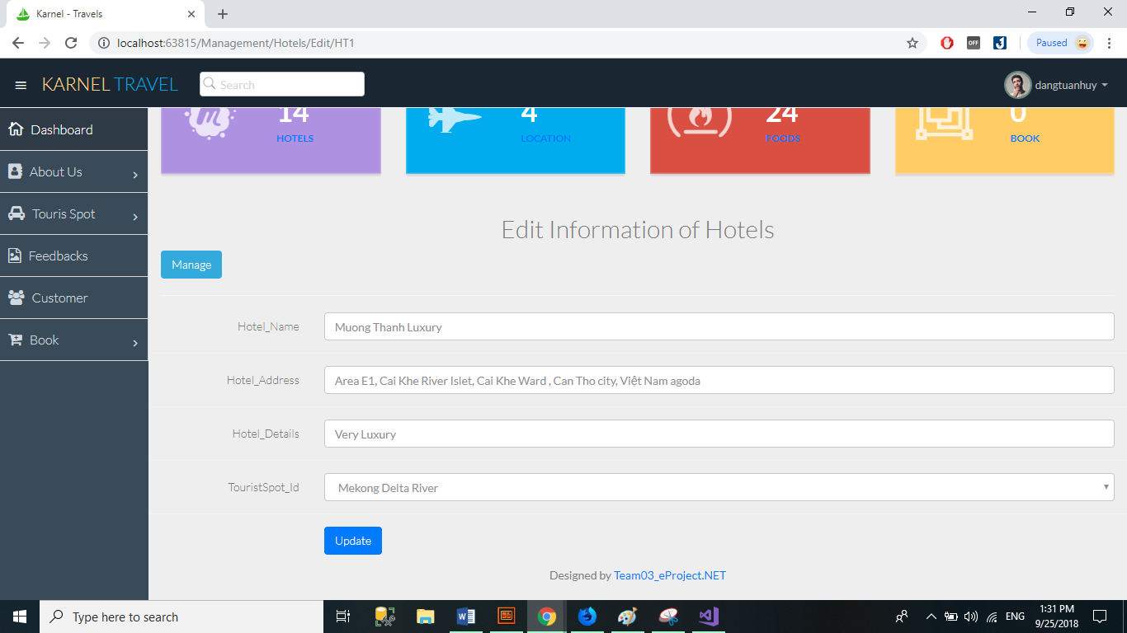Edit Hotels
* 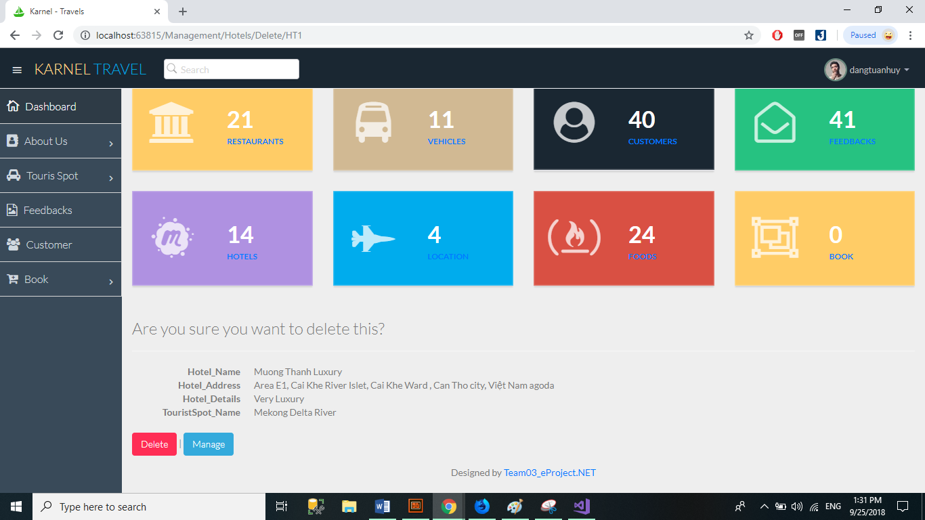Delete Hotels
* 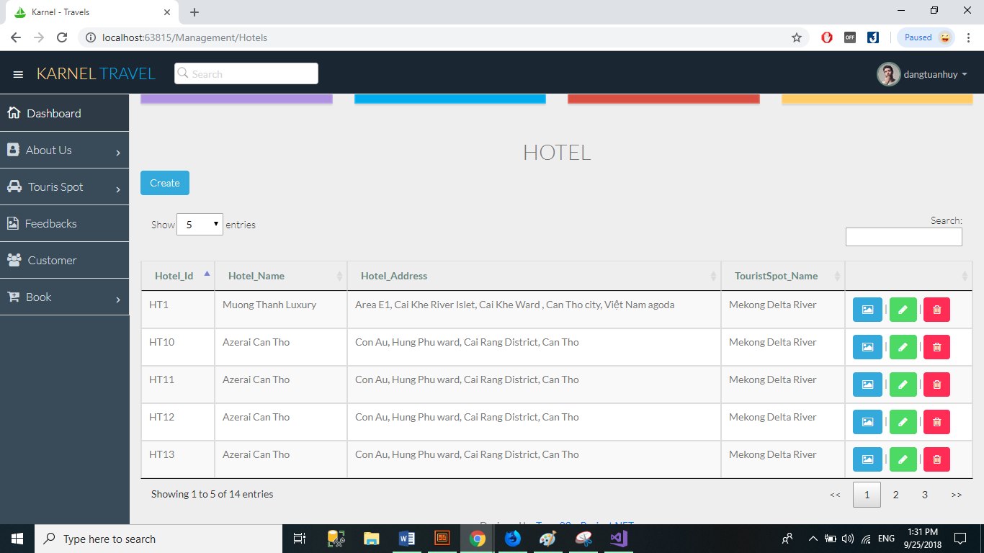List Hotels
* 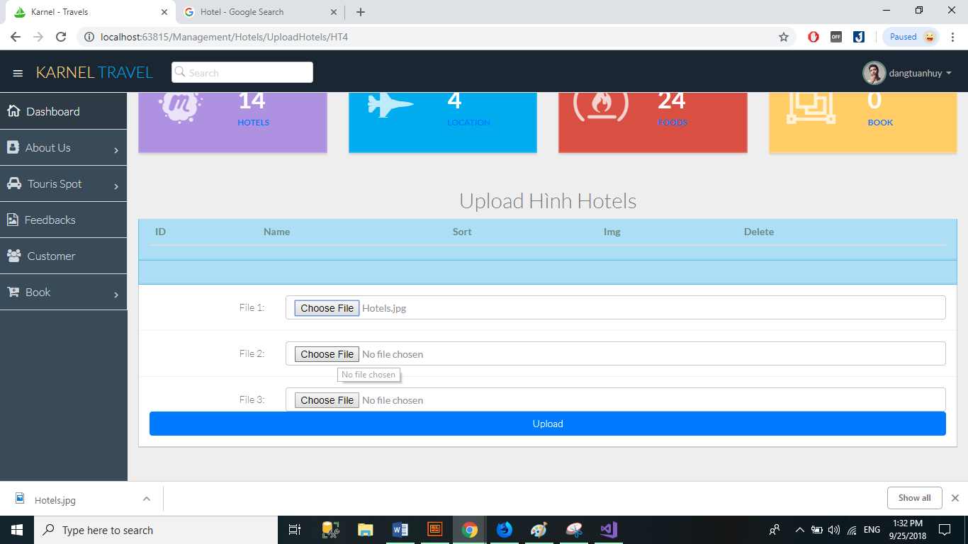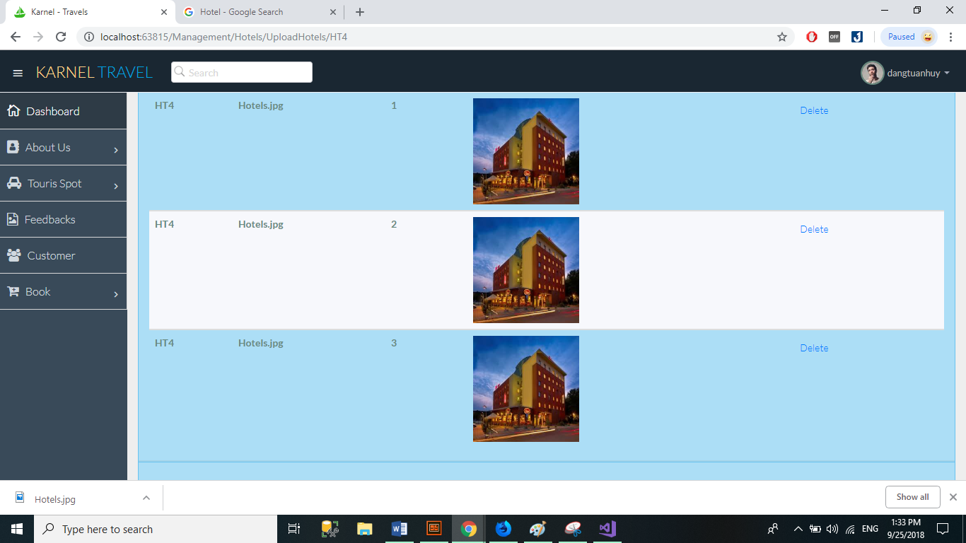Upload IMG Hotels
* 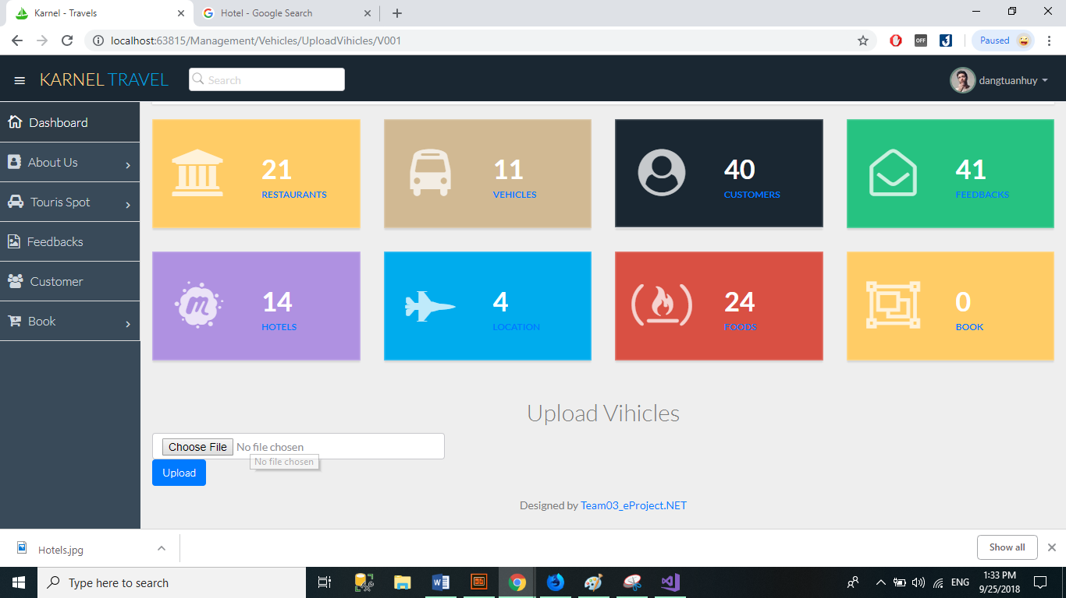Upload IMG Vehicles
* Statistics

13.3.3. User